Year 9- EOT Test Revision

Area, Surface Area and Volume

Question 1
Convert the following units:

- 33mm = __________ cm

- 0.00045m² = __________ cm²

- 4.2m³ = ___________cm³

Question 2
Find the area of the following. Give answer to 1 decimal place.

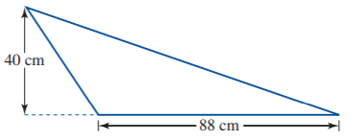

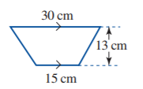

c.

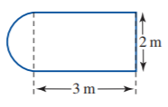

d.
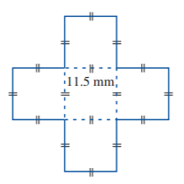

- Find the length of the side of the square:

Area = 36 cm²

Question 3
Find the surface area of each of the following prisms:

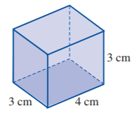

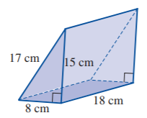

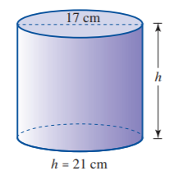

Question 4
Find the volume of the following prisms

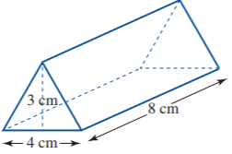

b.
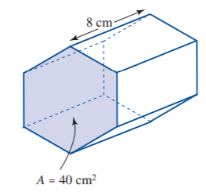

Question 5

A rectangular soccer field is to have new turf put down. If the dimensions of the ground are 105 m by 55 m, what area of turf needs to be ordered?

Question 6

A circular pizza tray comes in three sizes — a radius of 15 cm, 20 cm and 25 cm. Calculate the total area of the three trays.

Question 7

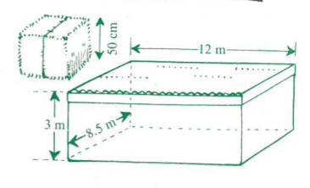

- A bale of straw is in the shape of a cube with a side of 50cm. Find the volume of one bale.

- A number of these bales are stored in a flat-topped shed 12 m long, 8.5m wide and 3 m high. What is the volume of the shed and how many bales will it be able to store?

